NAME: JEEVITHA.S-192324020
DATA BASE MANAGEMENT SYSTEM FOR WEB APPLICATION(CSA0555)
34. Dynamic SQL with a DDL Statement

CREATE PROCEDURE d_any_table(p_table_name VARCHAR2) IS
BEGIN
EXECUTE IMMEDIATE 'DROP TABLE ' || p_table_name;
END;

BEGIN d_any_table('EMPLOYEES101');
END;
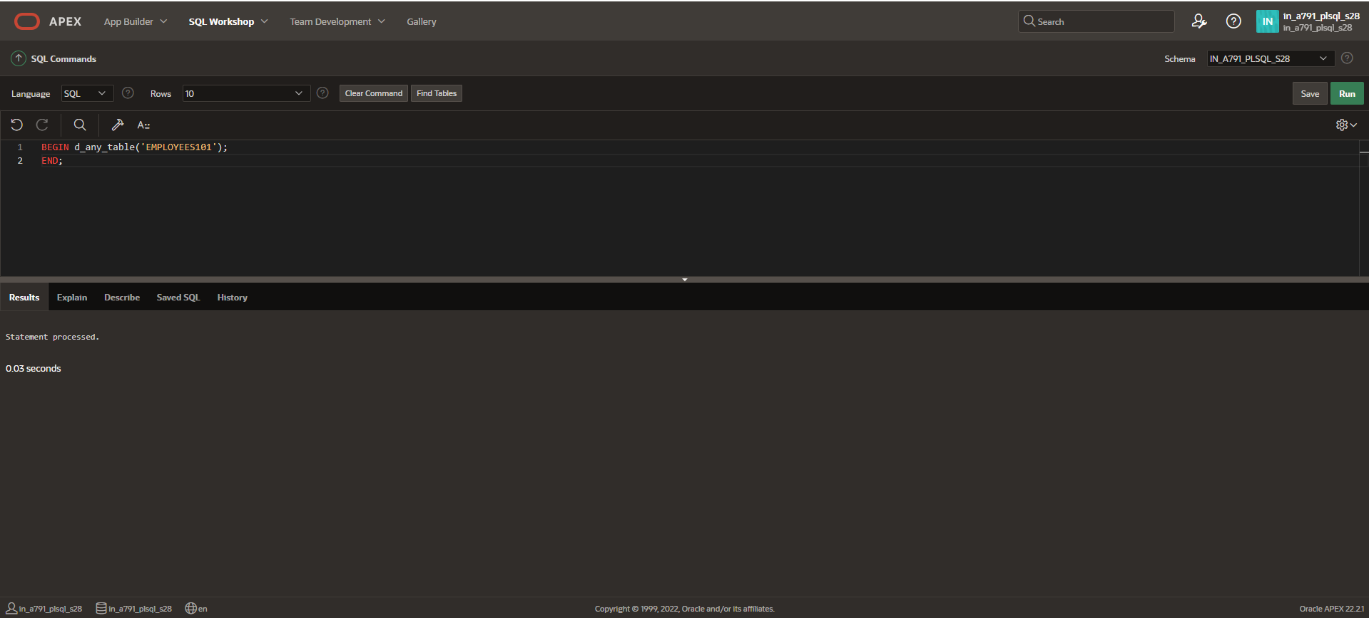
The Table will be dropped.

